DOCUMENTATION REPORT
(BIOMETRICS)

PROJECT TITLE: ALM Biometric Attendance Payroll System for ACLC College of Tacloban
TEAM NAME: BIOMETRICS
WEEK NUMBER: Week 4
COVERAGE PERIOD: April 2 – 6, 2026

WEEKLY SUMMARY:
During Week 4, the Biometrics team worked on optimizing the face enrollment process to address delays caused by slow recognition. The task included modifying the camera preview UI and streamlining the enrollment mechanism to improve system responsiveness. Moreover, the system is still under more improvements.

TASK TRACKER
Task Name: Face Enrollment Optimization
Description: Improving the face enrollment process to address delays caused by slow recognition during kiosk operations. Updating the camera preview UI.
Assigned To: Jane C. Marcellano
Start Date: April 2, 2026 (Thursday)
Target Date: April 3, 2026 (Friday)
Status: In Progress (Partially Completed)

Daily Updates
- Day 1: Fixing the face enrollment and changed the camera preview UI to circle instead of square.
- Day 2: Face enrollment optimized due to the kiosk’s slow face recognition.

Output / Proof:
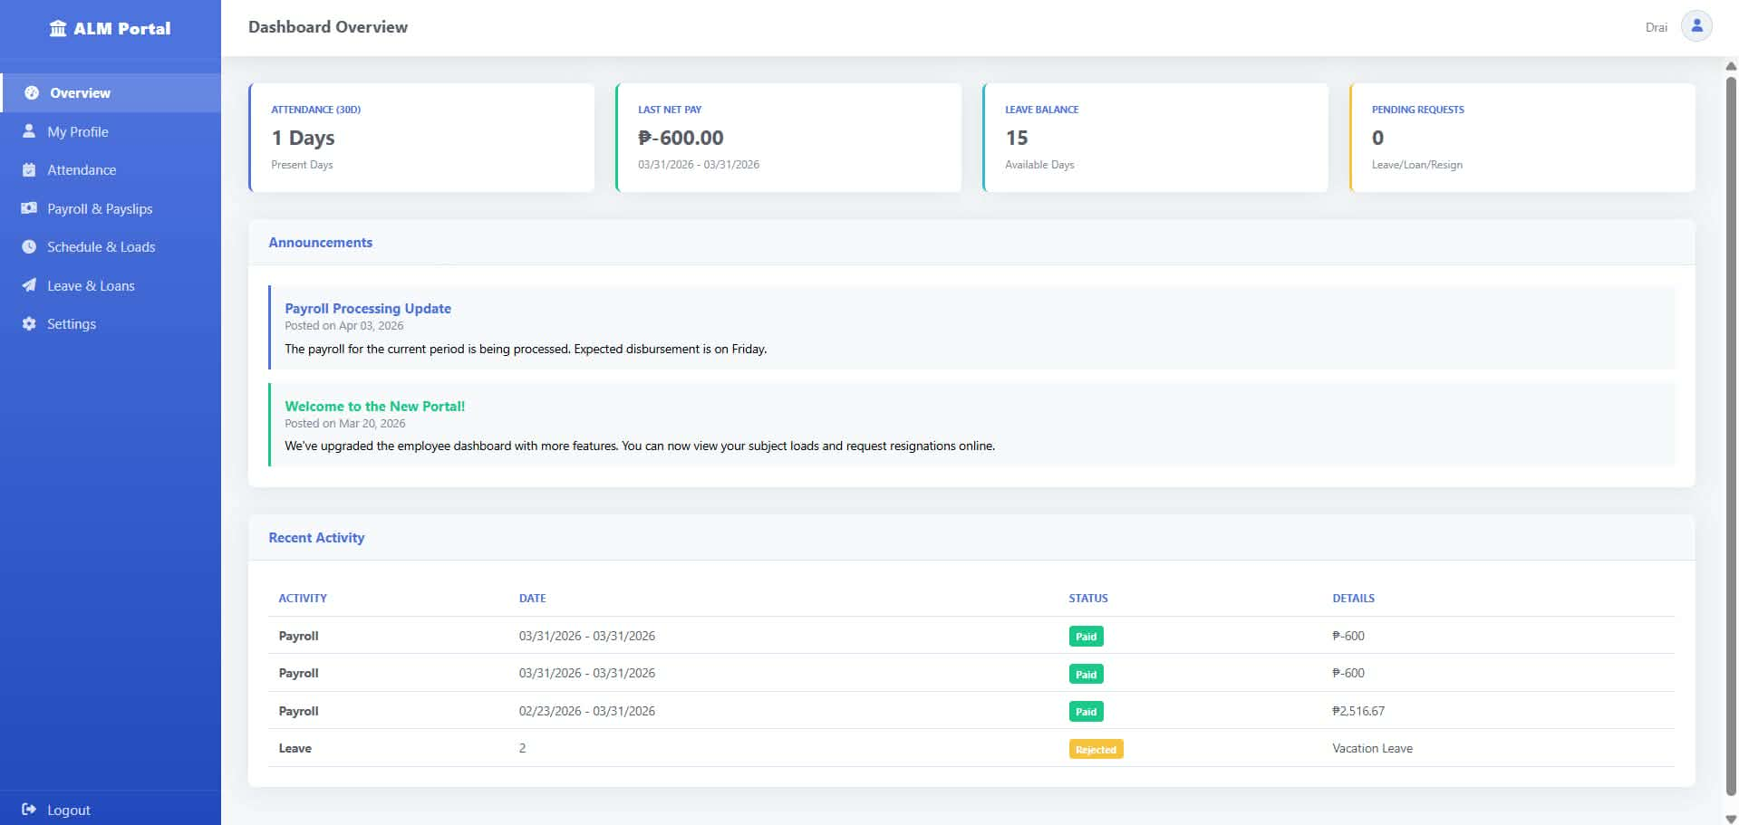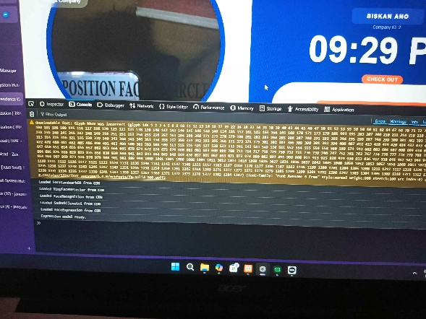
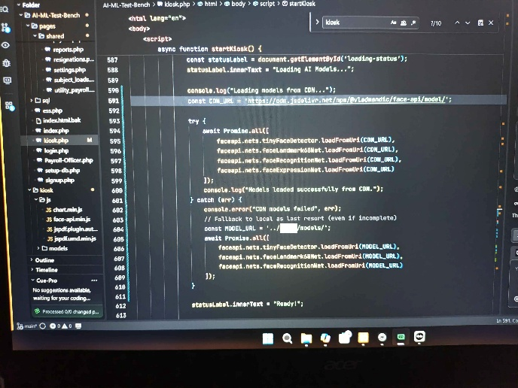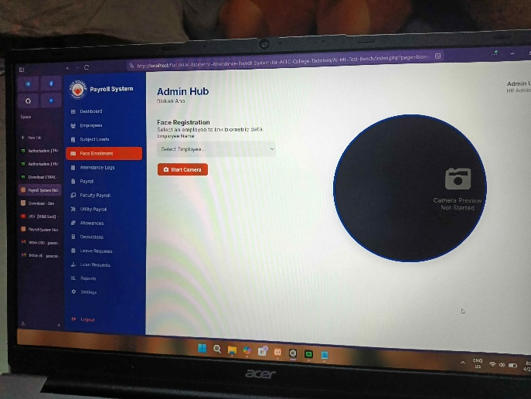
Issues:
- Struggle with slow face recognition causing delays.
Resolution:
- The face enrollment process was optimized to ensure that face recognition operates efficiently and no longer experiences delays.
______________________________________________________________________

TASK TRACKER
Task Name: Multi-face Handling Implementation
Description: Implemented a feature that detects multiple faces using the webcam and prevents attendance recording of more than one face is detected. Displays an instruction message to ensure only one face is visible.
Assigned To: Ruffa Mae Padel
Start Date: April 5, 2026 (Sunday)
Target Date: April 6, 2026 (Monday)
Status: In Progress (Partially Completed)

Daily Updates
- Day 1: Sets up face detection using the face_recognition library, added a condition to reject multiple faces, and displayed an instruction message. Tested the system with different scenarios to confirm proper functionality.

Output / Proof:
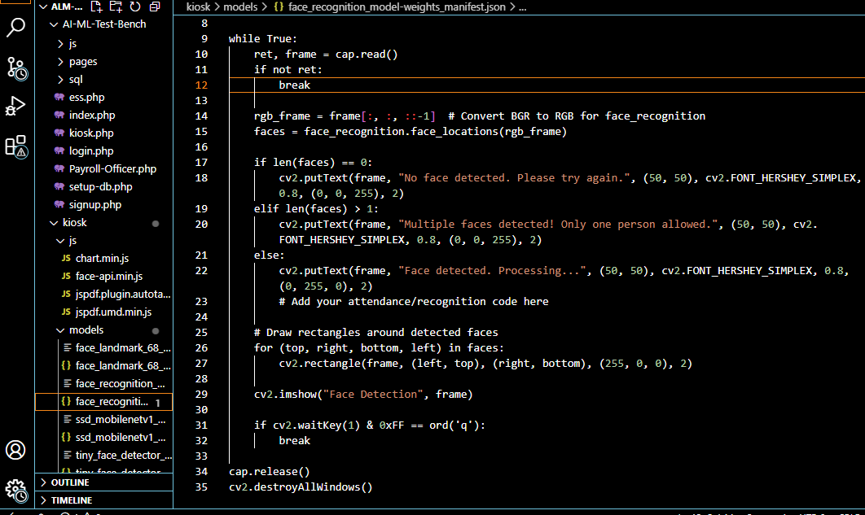

Issues:
- N/A
Resolution:
- N/A
_________________________________________________________________________

TEAM CONTRIBUTION: (Not in list, not contributed)
- Jane C. Marcellano > 1 task > In progress (Partially Completed)
- Ruffa Mae Padel > 1 task > In progress (Partially Completed)

NEXT WEEK PLAN:
- General Face Enrollment
- Kiosk Functionalities 95% Finished

